Exercise 1 (10 points): Create an ER diagram based on the following requirements. Show entities, relationships, and attributes. You can use any notation, just be coherent.
Andy’s Motors is a car dealership that keeps track of:
- For each sales employee: salesename, startdate, number of years with dealership (yearswith), unique salesessn, unique salesID.
- For each service employee: serviceefname, unique serviceessn, unique serviceeID.
- For each customer: cname (composed of cfname and clname), phonenumber, unique cid.
- For each vehicle: year, make, model, unique VIN
- For each repair appointment: raptdate, unique raptID.
Additional requirements:
- A sales employee must have at least one assigned customer but can have many assigned customers.
Each customer is assigned to one sales employee
- A vehicle is owned by exactly one customer.
Each customer owns at least one vehicle but may own many.
- A vehicle may have many repair appointments but does not have to have any.
Each repair appointment is associated with one vehicle.
- Each service employee participates in between zero and many repair appointments.
Each repair appointment has at least one service employee participating in it but can have up to four service employees participating in it.
- Each sales employee has exactly one service employee assigned as their tech expert.
A service employee can be assigned to up to three sales employees as a tech expert, but does not have to be assigned to any.

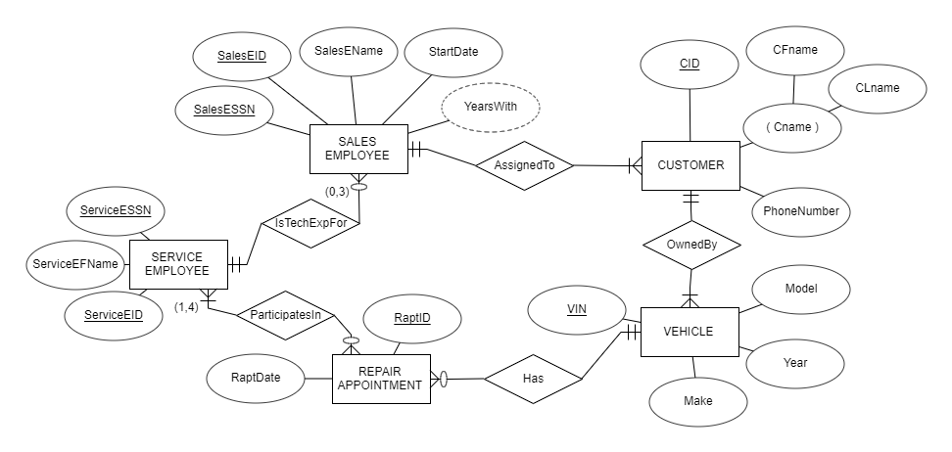

Exercise 2 (10 points)
Find the following relational database schema and draw the ER diagram that was the basis of this relational schema. You can use any notation, just be coherent.

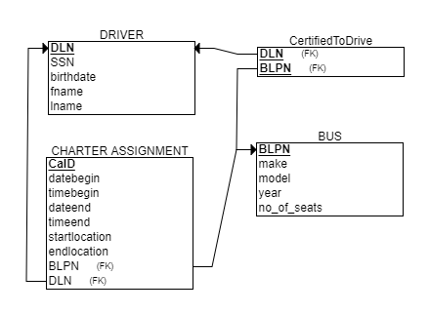

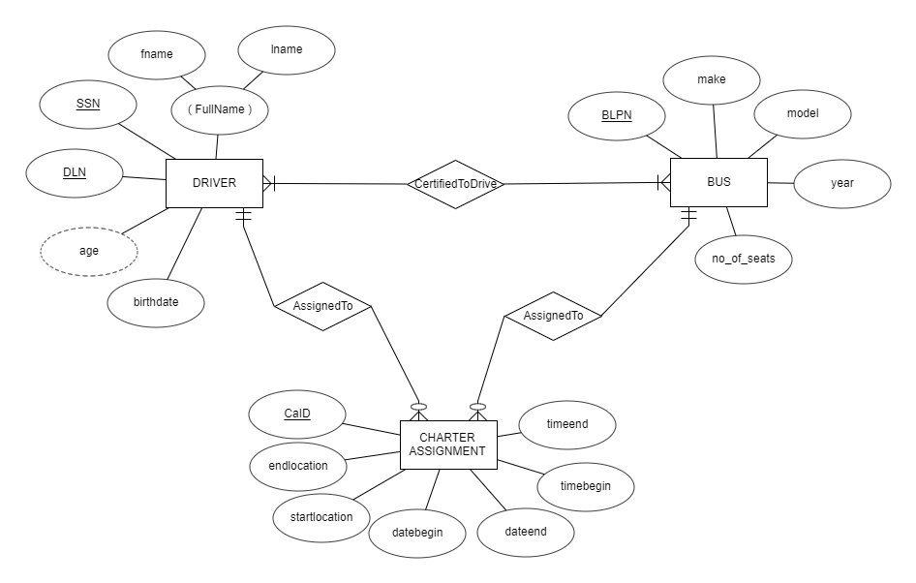

Exercise 3. Multiple choice question (SQL) (10 points, 1 point for the right answer, 0 for no answer or wrong answer). One and only one right answer for each question. Use the grid below to answer the question.

Question | A | B | C | D
1 |  |  | x
2 |  |  |  | x
3 |  | x
4 |  |  | x
5 |  | x
6 |  | x
7 | x
8 | x
9 |  | x
10 |  | x

1. What is the result of the following SQL query?

SELECT ename, esalary * 1.15 FROM employee;

A) For each employee, the query will display the name and the salary increased by 15 dollars
B) For each employee, the query will display the name, the salary, all other columns from the table employee, and the number 1.15
C) For each employee, the query will display the name and the salary increased by 15%
D) For each employee, the query will display the name and 15% of the salary

2. Observe the table STUDENT:

STUDENT
StudentID SSN Name Class
D111 111-11-1111 Connor Freshman
D222 222-22-2222 Trevor Freshman
D333 333-33-3333 Connor Sophomore
D444 444-44-4444 Parker Sophomore
D555 555-55-5555 Connor Sophomore

What will be the result of the following query on table STUDENT?

SELECT COUNT( *) FROM student GROUP BY class;

A) Number 5
B) Number 2
C) Number 3
D) Numbers 2 and 3
3. Considering the same STUDENT table. What will be the result of the following query on table STUDENT?

SELECT COUNT( *) FROM student GROUP BY class HAVING COUNT(*) <3;

A) Number 5
B) Number 2
C) Number 3
D) Numbers 1 and 1

4. Observe the DOCTORS AND SPECIALTIES database:

DOCTOR
DocID | DocName | NoOfPatients | SpecID
111 | Jill | 20 | SUR
222 | Linda | 20 | SUR
333 | Lisa | 30 | RAD
444 | Sue | 15 | ANE
555 | Lola | 15 | ANE

SPECIALTY
SpecID | SpecName
SUR | Surgery
RAD | Radiology
ANE | Anesthesiology

What will be the result of the following query?

SELECT sum(noofpatients) FROM doctor
WHERE specid = 'SUR';

A) 2
B) 20
C) 40
D) 70

5. Which of the following SQL statements will return a list of all doctors along with their specialty names?

A) SELECT DocName, SpecName
FROM DOCTOR;

B) SELECT DocName, SpecName
FROM DOCTOR
JOIN SPECIALTY
ON DOCTOR.SpecID = SPECIALTY.SpecID;

C) SELECT DocName, SpecID
FROM DOCTOR
WHERE SpecID = 'RAD';
D) SELECT DocName, NoOfPatients
FROM DOCTOR
WHERE NoOfPatients > 20;

6. What will be returned when the following SQL statement is executed?

SELECT employee_id, count(*) as num_sales
FROM sales
WHERE region = 'CA'
GROUP BY employee_id;

A) A listing of all employees who made sales in region = 'CA', sorted by employee ID
B) A listing of each employee who made sales in region = 'CA' as well as the number of sales that each employee has made in that region
C) A count of all of the sales made in region = 'CA' by all employees
D) An error message will be generated

7. Observe the HOMETOWN REALESTATE database:

SELLER
SellerID | SellerName | RealtorID
S111 | Paul | R1
S222 | Carly | R1
S333 | Ana | R2
S444 | Charlotte | R2
S555 | Aidan | R3
C666 | Eric | R1
C777 | Christina | R1

REALTOR
RealtorID | RealtorName
R1 | Claire
R2 | Kate
R3 | Cliff
R4 | William

If a DBMS enforces a DELETE RESTRICT option on the referential integrity constraint between SELLER and REALTOR in the HOMETOWN REALESTATE database, what will be the outcome after a user tries to delete the first record (R1, Claire) from REALTOR?
A) SELLER will have 7 records, REALTOR will have 4 records
B) SELLER will have 3 records, REALTOR will have 3 records
C) SELLER will have 7 records, REALTOR will have 3 records
D) SELLER will have 6 records, REALTOR will have 4 records

8. Which of the following is a part of a DDL statement?

A) CREATE
B) INSERT
C) DELETE
D) SELECT

9. What is the result of the following SQL statement?

UPDATE employee
SET salary = salary + 5000
WHERE department_id IN (101, 102)
AND salary < 40000;

A) The salaries of all employees in departments 101 and 102 will be increased by 5000.
B) The salaries of employees in departments 101 and 102 earning less than 40000 will be increased by 5000.
C) The salaries of employees in all departments earning less than 40000 will be increased by 5000.
D) An error will occur because the IN clause cannot be used with multiple values in this context.
10. What will be the result of the following SQL statement?
SELECT e.employee_id, e.first_name, d.department_name
FROM employees e
LEFT JOIN departments d
ON e.department_id = d.department_id;

A) A list of all employees, including their department names, but only for employees who are assigned to a department.
B) A list of all employees, including their department names, and for employees without a department, the department name will be NULL.
C) A list of all departments, including employee names, but only for departments with assigned employees.
D) An error will occur because LEFT JOIN requires matching rows in both tables.

Exercise 4. Fill in the blanks with missing element(s) of the code. 1 point per missing, 1 point for the right answer, 0 for no or wrong answer. Attention, one or more words, parentheses, other symbols (for example “ , ;) may be missing.

1. From the Student table before, write an SQL query on the table STUDENT that for each class that has more than 2 students, lists the class and the number of students in the class.

SELECT class, ______
FROM student
GROUP BY _____
HAVING COUNT(*) > 2;

SELECT class, COUNT(*)
FROM student
GROUP BY class
HAVING COUNT(*) > 2;

2. Considering the HOMETOWN REALESTATE database from the prior exercise, Show the CREATE TABLE statements for HOMETOWN REALESTATE database for the table SELLER (assume that non-primary key columns can be optional) with the DELETE CASCADE option for its referential integrity constraint.

CREATE TABLE seller
(sellerid CHAR(4) PRIMARY KEY,
sellername CHAR(10),
realtorid INT,
FOREIGN KEY (_______) REFERENCES realtor (realtorid)
_______________);

CREATE TABLE seller
(sellerid CHAR(4) PRIMARY KEY,
sellername CHAR(10),
realtorid INT,
PRIMARY KEY (sellerid),
FOREIGN KEY (realtorid) REFERENCES realtor (realtorid)
ON DELETE CASCADE);

3. If we want to list all products that have a non-null price, we need the following query:
SELECT *
FROM Products
WHERE price____________;

SELECT *
FROM Products
WHERE price IS NOT NULL;

4. If we want to query to display the name of the employee (or employees) with the highest salary, this is the query we need to follow:

SELECT ename
FROM employee
________ esalary = (SELECT MAX(esalary) FROM employee);

SELECT ename
FROM employee
WHERE esalary = (SELECT MAX(esalary) FROM employee);

5. Complete the following query if we want one single table with information about the employee department and employee names of those employees working in the same department, sorted alphabetically.
SELECT
e1.department_name,
e1.first_name AS employee_1_first, e1.last_name AS employee_1_last,
e2.first_name AS employee_2_first, e2.last_name AS employee_2_last
FROM
hr.employees e1
INNER JOIN hr.employees e2 ______ e1.employee_id <> e2.employee_id
______ e1.department_id = e2.department_id
ORDER BY
department_name,
employee_1_last,
employee_2_last;

SELECT
e1.department_name,
e1.first_name AS employee_1_first, e1.last_name AS employee_1_last,
e2.first_name AS employee_2_first, e2.last_name AS employee_2_last
FROM
hr.employees e1
INNER JOIN hr.employees e2 ON e1.employee_id <> e2.employee_id
AND e1.department_id = e2.department_id
ORDER BY
department_name,
employee_1_last,
employee_2_last;

6. Fill in the blank to complete the query that calculates the total number of orders for each custome

SELECT customer_id, _______ AS total_orders
FROM orders
GROUP BY customer_id;

SELECT customer_id, COUNT(*) AS total_orders
FROM orders
GROUP BY customer_id;

7. We want to get all data from the employee table where the job title ends with 'Manager':
SELECT *
FROM employees
WHERE job_title __________;

SELECT *
FROM employees
WHERE job_title LIKE '%Manager';

